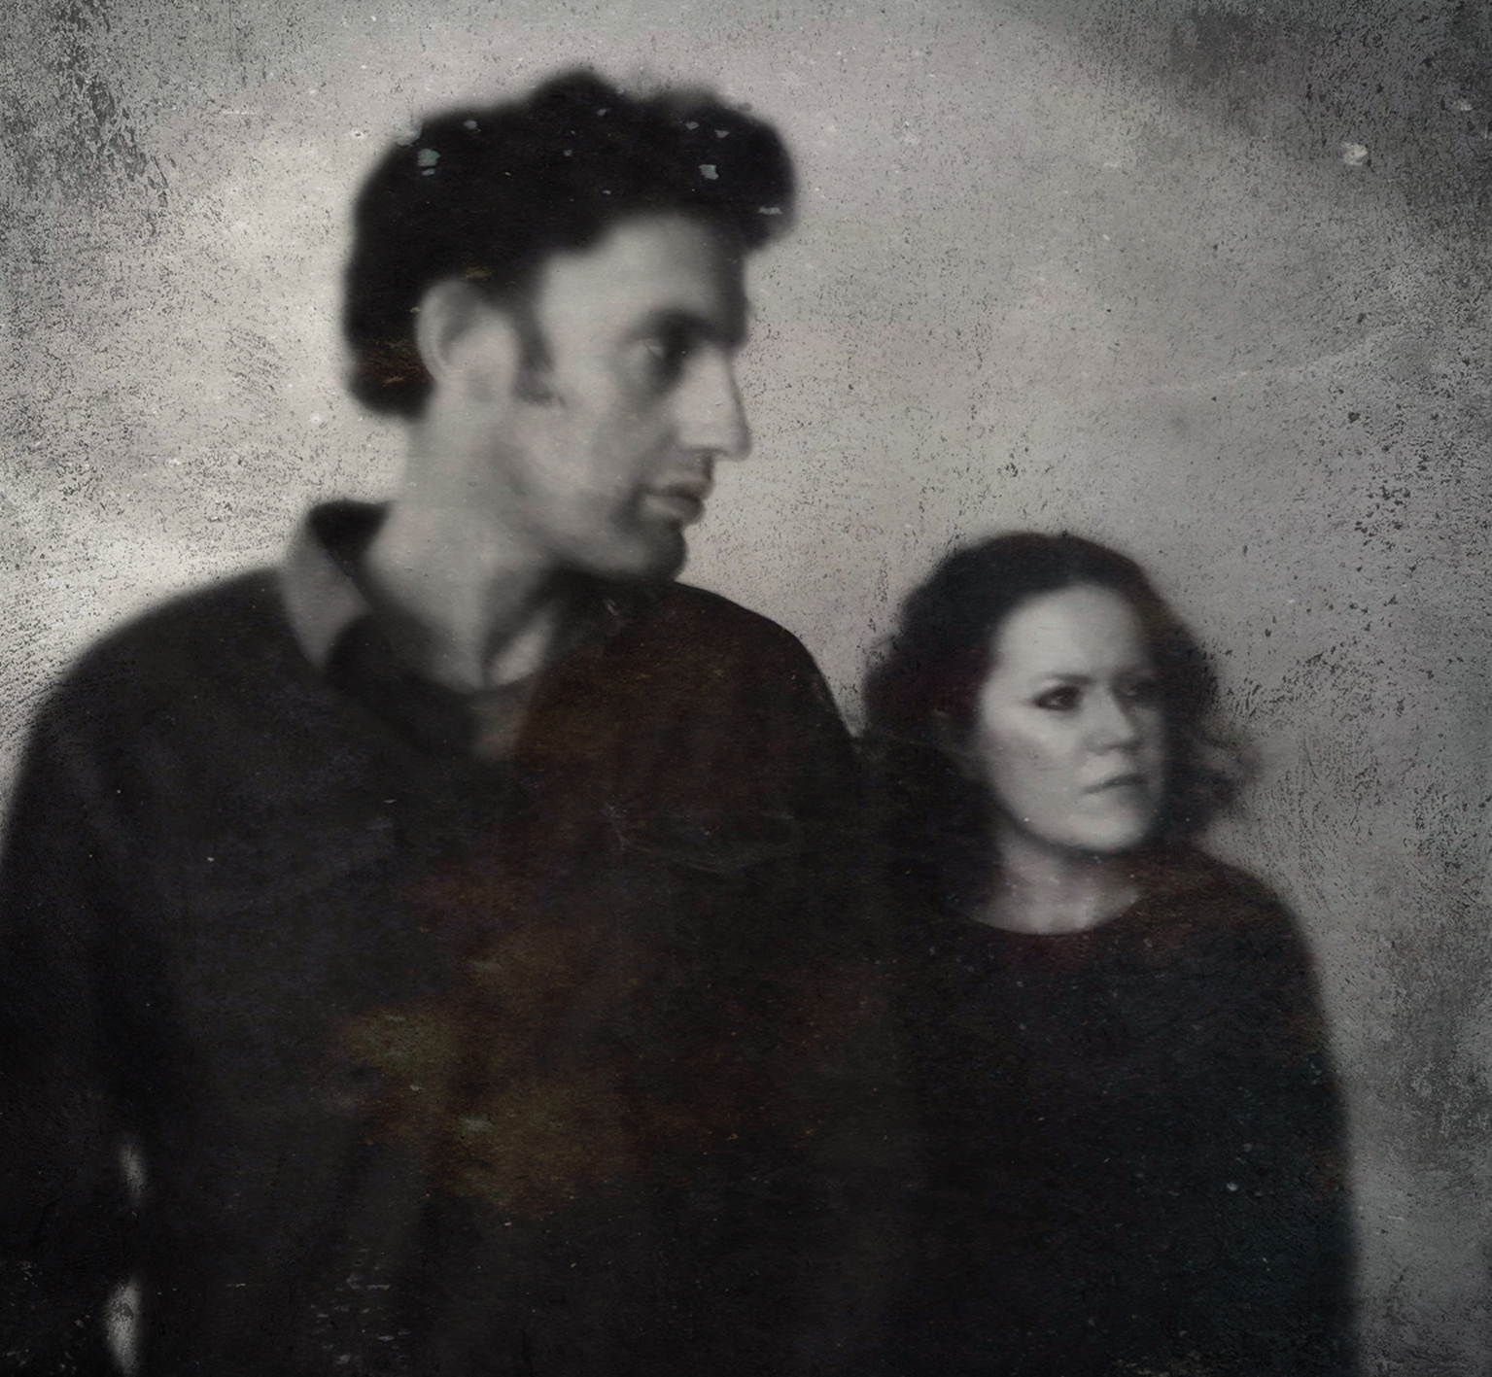Doghouse Roses

‘Lost Is Not losing’

Release Date – November 25th
Label: Yellowroom Music YLLWRM-010

www.doghouseroses.net

‘In Iona Macdonald’s singing resides a lovliness that cannot be taught’ Rolling Stone, Germany

‘[Paul Tasker] is one of the guitarists of his generation’ Maverick Magazine

Glasgow’s Doghouse Roses once more present their unique take on contemporary folk and reaffirm that they are ‘Something a little bit special’ (The List) with the release of their long-awaited third studio album ‘Lost is Not Losing’.

In 2014, an invitation to open for Television brought the pairing back to the stage for the first time in almost 2 years. Inevitably, this lead to the realisation that both had been unintentionally writing songs destined for the duo. Once seasoned with the progressive fingerpicking of Tasker’s guitar and the impelling vocal delivery of Macdonald, recording became the inevitable next step. Whilst the almost constant comparisons to Sandy Denny and Bert Jansch might leave some to expect yet another attempt at reviving the folk revival of the 1960’s, the colours on display here are contemporary reflections.

‘Pour’, is a defiant and quirky opening track, telling a tangled tale of love and alcoholism, brought to life by Craig Laurie on drums and Stephen McGourty on bass. ‘Feed the Monster’, ‘New Year Rag’ and ‘After Sun’ are overtly political, but without the oft dictatorial edge of protest songs. “Life is political”, according to Iona. “Politics isn’t about detached politicians. It’s about how we choose to live our lives every day and how we choose to treat the people and the world around us. It’s about the questions we ask.”

The band shifts into classic country territory for the leaving song, Diesel Engine complete with guest co lead vocal from Biff Smith of ‘A New International’ and stinging lead guitar from Slovenian virtuoso Dejan Lapanja. Backing vocals are provided by Jo Shaw and Katie Macarthur, who also perfectly complements Iona Macdonald’s voice by providing harmonies on the Ballad of a former prostitute, ‘Fairground’. John Alexander adds acoustic guitar to ‘ To Decide’ and ‘Days of Grass and Sun’, and the album is fully realised by Laura-Beth Salter on mandolin and Jez Hellard on harmonica.

There is often dark humour and a rich seam of inspiration to be found when life leads you off the beaten track, through the dark cities and scattered bars of ‘Lost Is Not Losing’. For an album that is borne from tales of the road, it is only fitting that Tasker and Macdonald take the songs back to their breeding ground as they embark on a German tour in the winter, with UK dates to follow in April 2017

Lost Is Not Losing Track Listing

- Pour
- To Decide
- Feed The Monster
- The Whistle Song
- Weather The Storm
- Fairground
- Crooked Life
- After Sun
- Diesel Engine
- New Year Rag
- Days of Grass and Sun

Upcoming Tour Dates:

NOV25 2016: Glasgow Venue TBC
DEC 02 2016: BERLIN – Artliners
DEC 03 2016: WEIMAR – Weinkelterei Appenrodt
DEC 04 2016: LAMPENHAUN – Rathaus
DEC 06 2016: VILLINGEN-SCHWENNINGEN – Scheuer
DEC 08 2016: HEILBRONN – Red River
DEC 09 2016: SCHOENENBERG-KÜBELBERG – Schleppi’s
DEC 10 2016: NEUSTADT/W.-GIMMELINGEN – Alte Turnhalle
DEC 11 2016: BAD BRAMBACH – Café Grenzland
DEC 12 2016: OEDERAN – Klein-Erzgebirge

JAN 08 2017: EDINBURGH- The Royal Oak

